**UCS 414: LAB Assignment 6**

1. Configuring a Router
   1. Initial Configuration of Router
   2. Configure Telnet, Consol password, privileged mode password and VTY lines password, Secure Shell
   3. Configure serial interfaces DTE and DCE

**Solution:**

# Introduction

To connect to the router we execute Internetworking Operating System (IOS) commands. IOS is a software that runs on all routers and allows the user to manage and configure the processes that occur on the router. IOS is command- line interface (CLI) software which accepts user commands and displays router output.

As a security feature, Cisco IOS provides separate commands into two different access level modes; user EXEC level and privileged EXEC level.

**User EXEC level**: allows a person to access only a limited number of basic monitoring commands. In this mode, the router or switch prompt is displayed as:

# hostname>

The right arrow (>) in the prompt indicates that the router or switch is at the user EXEC mode.

Privileged EXEC level: allows a person to access all router commands (including configuration and management) and can be password protected to allow only authorized people to access the router. In this mode the symbol “# “ is displayed as the prompt.

# hostname#

Router commands

**Router > show** show running system information

**Router > where** list active connections

**Router > sh?** List all commands that begins with “sh”

Press the up arrow to see or reuse the last entered command. Press it again to go to the command before that. Press the down arrow to go back through the list.

# Enter the Privileged EXEC level. Router > enable [Enter]

Use the Help command ? to see the list of available commands in the privileged level.

# Router # ?

Practice the frequently used privileged commands below:

**Router# show ip interface** Learn about the status of the interfaces of this router

**Router# show run** View the configuration of the router

**Router# show running-config** View the Running Configuration. (There are two different configurations stored on the router; the Running Configuration and the Start‐Up Configuration. The

Running Configuration is your current, working configuration. It is stored in the

**RAM** memory of the router.)

**Router# show startup-config** View the Start‐Up configuration. It is the configuration that

is loaded when the router initializes

**Router# show version** Find the version and system information about your router

**Router# show memory** Find memory information about the router

# Router# configure terminal

**Router(config)# hostname r1** Change the router name from “Router” to “r1”. The command prompt will look now **r1(config)#**

**Router(config)# <CTRL>+Z** Switch from configuration to privileged mode

In

In the **Privileged EXEC** level use the show command to see detailed information about the network interfaces of the router.

# Router # show interfaces [Enter]

Now enter the Configuration level to assign an IP address to the router.

# Router# configure terminal [Enter]

Use an IP address (eg. 10.128.20.254) and subnet mask 255.255.0.0 for the values. Then do the following:

# Router(config) # interface fa 0/0 [Enter]

This will ensure that you are configuring the 0/0 interface since there could be multiple interfaces with names 0/0, 0/1 …etc.

**Router(config**‐**if ) # ip address** (given ip address) (given subnet mask) **[Enter]**

# e.g. ip address 10.10.10.1/30

**Router(config**‐**if ) #no shutdown [Enter]** This will ensure that the ip address configuration is administratively up. i.e. The ip address is being used for routing purpose.

Connect the router to the PC using the Crossover cable. Change the IP address of your computer by doing the following.

Enter the IP address, subnet mask and default gateway (the IP address for the router) and click **ok**. Here use the following values:

# IP address (of your computer): 10.128.20.1 Subnet mask: 255.255.0.0

**Default gateway: 10.128.20.254**

**If setting for Router use command R1#**.-> ip route 0.0.0.0 0.0.0.0 10.128.20.254

To check the connection between your computer and the router, ping the ip address of the router. Type ping from the PC DOS window and from the router privileged EXEC login window.

**Setting Router Passwords**

So far we have been working on a router with no access restrictions enabled. In the real world, this is not the case. The most basic form of access restriction would be by the use of passwords. Passwords can be set for console access, telnet access and privileged EXEC access. Below are the various password commands on a Cisco router. The commands have to be typed out in privileged EXEC mode.

Set a console password Router(config)#**line con 0** Router(config-line)#**login** Router(config-line)#**password cisco**

Set a telnet password. This command is also used to enable telnet access for up to 5 simultaneous logins

Router(config)#**line vty 0 4** Router(config-line)#**login** Router(config-line)#**password cisco**

Stop console timing out in cases of inactivity Router(config)#**line con 0**

Router(config-line)#**exec-timeout 0 0**

Set the enable password to cisco Router(config)#**enable password cisco**

Set the enable secret password to peter.

This password overrides the enable password and is encypted within the config file

Router(config)#**enable secret peter**

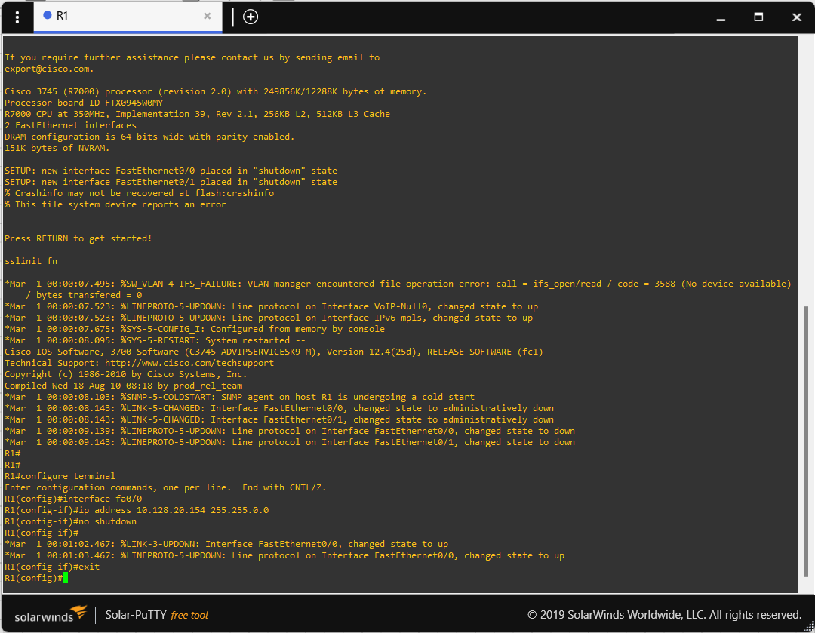**Set IP Address**

**Enable Router Password**

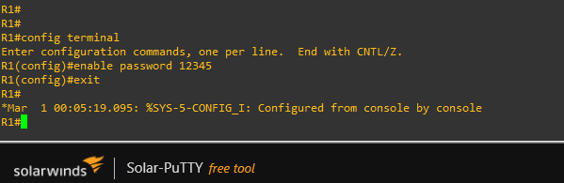

**Set console password**

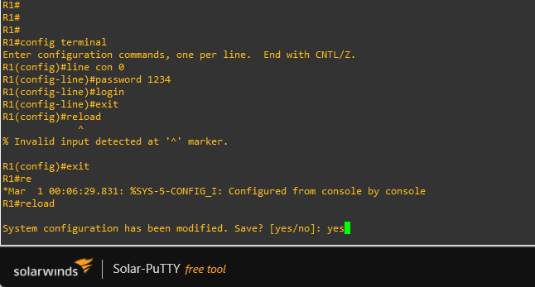

**Show ip interface**

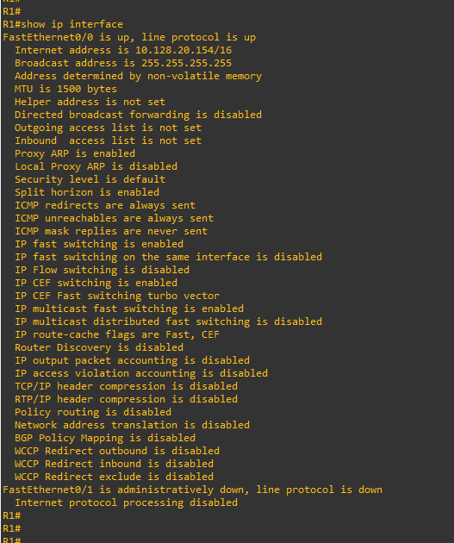

**Show running and startup configurations**

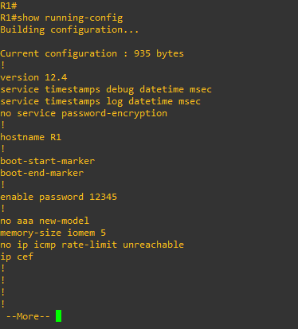

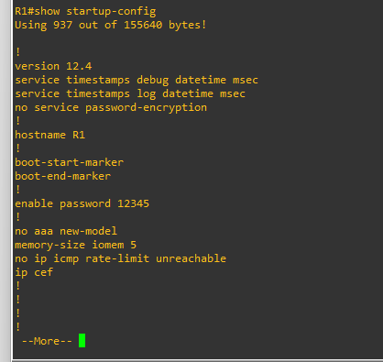

**Show memory**

